3.4 Test Operating System Platform

Date Tested | Operating System | Browser | Functions Tested | Result | Evidence
25/09/2026 | Windows11 | Microsoft Edge | Login, registration, patient search, tracking | Pass | Screenshot
25/09/2026 | Mac OS | Safari | Login, registration, patient search | Not Tested – No Mac available | –
25/09/2026 | iOS | Safari | Login, navigation, registration | Pass | Screenshot

3.4.1 Microsoft Edge
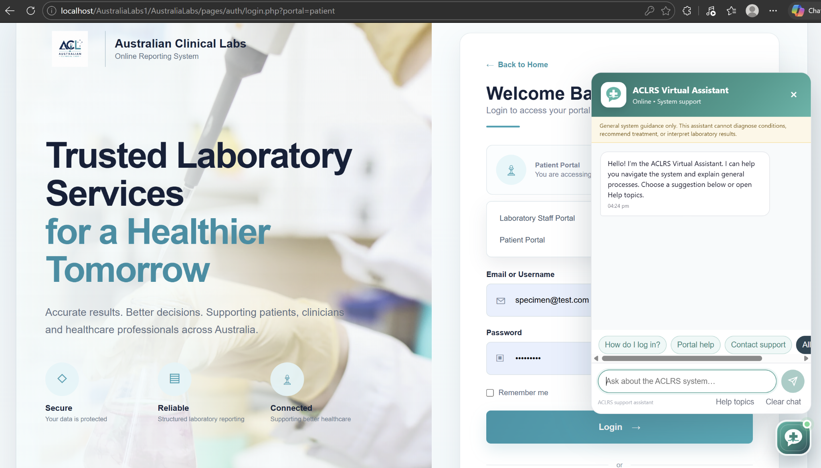
Figure 3.4.1 – System tested on Windows

3.4.2 Mac OS

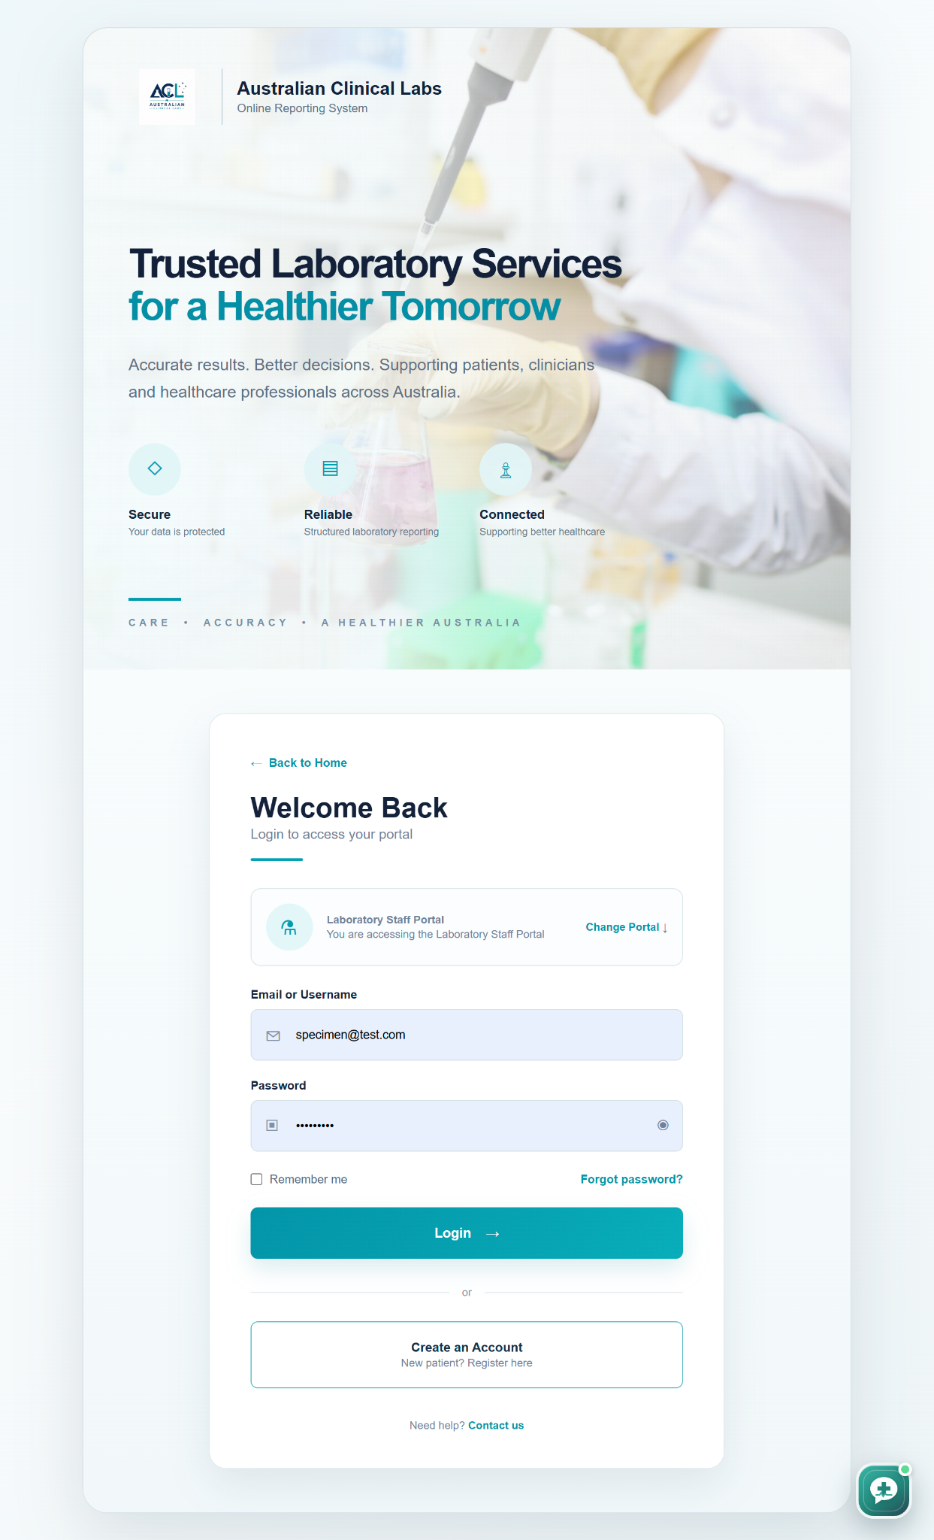
Figure 3.4.2 – System tested on macOS

3.4.3 iOS

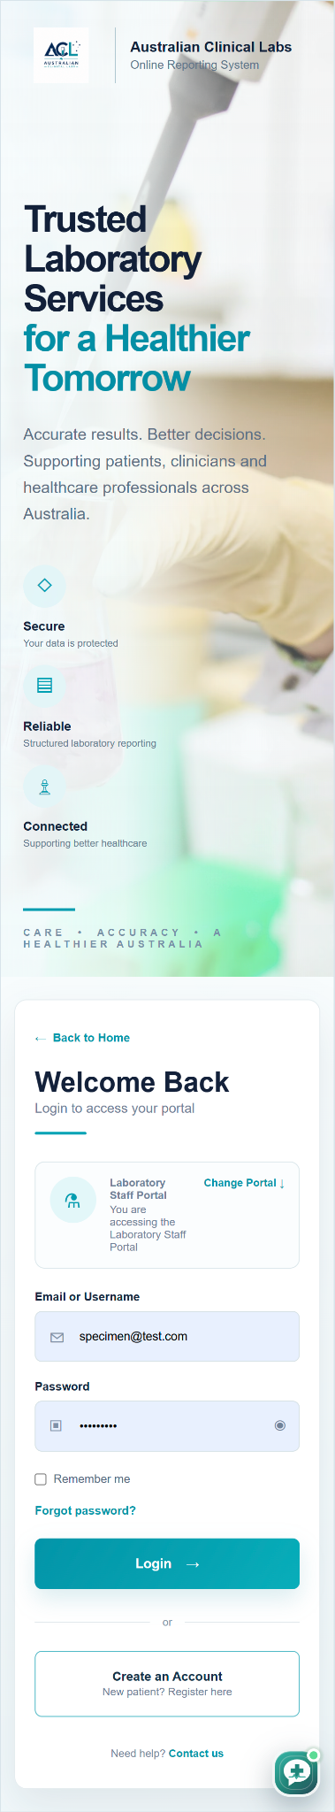
Figure 3.4.3 – System tested on iOS

